MODERSOHN-BECKER, PAULA (1876–1907)

Paula Modersohn-Becker was born in Dresden and moved to Bremen with her family in 1888. After finishing her studies at a teacher training college, she enrolled in an academy of drawing and painting for women in Berlin. In 1898 she moved to the artists’ colony Worpswede, a village north of Bremen, to continue her education under the painter Fritz Mackensen. There she met Heinrich Vogeler, Clara Westhoff, Rainer Maria Rilke, and Otto Modersohn, the latter she married in 1901. She travelled to Paris for the first time in 1900. Three subsequent stays in this cultural metropolis led her to develop a new, distinctive and monumental style of painting. Her work was particularly influenced by Paul Cézanne, Paul Gauguin, and the Nabis. However, Modersohn-Becker was also fascinated by antiquity, especially Egyptian mummy portraits, and the works of the Old Masters she saw in the Louvre. Following her last stay in Paris from February 1906 to March 1907, she returned to Worpswede where she gave birth to her only child, Mathilde, in November 1907, and subsequently died of an embolism two weeks later.

Modersohn-Becker was indubitably one of the pioneers of European modern painting. Due to her early death at the age of 31, she had only ten years of artistic activity. But within this time she accomplished an astonishing range of works and left behind an influential body of work, notably self-portraits and renderings of children and women. She usually selected local children, old women, or farmers’ wives as models for her portraits and figure studies and developed a pictorial idiom that gives expression to the essential character of the given individual. Her later works, in particular, exhibit an unmistakable monumentality as well as simplicity of form. This simplicity of form is not only characteristic for her figures but also for her landscapes and still lifes. The surface structure of her works is also distinctive: by scratching into the wet paint with the back of her brush, she obtains a relief-like modelling of the surface evoking a vibrant and lively atmosphere.

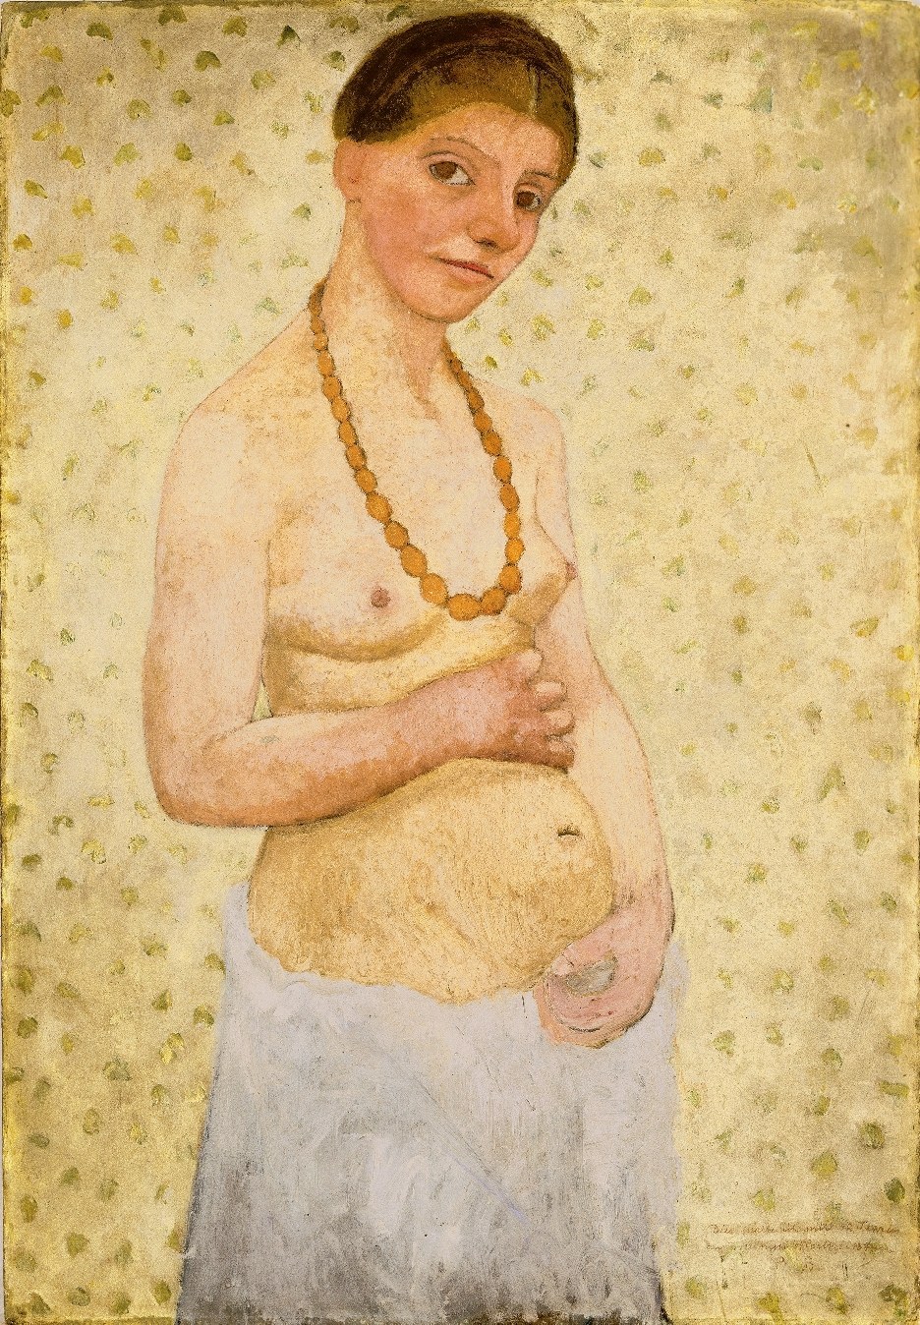
With Self-Portrait on Her 6thWedding Anniversary of 1906 Modersohn-Becker created an iconic work in the history of art – the first nude self-portrait of a woman. Not only was this self-portrait a revolution, her almost life-sized full-body nude self-portrait from the same year, Large Standing Self-Portrait Nude (Summer 1906), was also sensationally modern. Modersohn-Becker succeeded in adding a new contentual dimension to the female nude by concentrating on depicting a body in its natural, elementary state devoid of exhibitionistic posing. By using attributes like flowers and fruits as well as an archaic-like body language she underlined the nativeness of the body. With her courageous nude self-portraits and figures, Modersohn-Becker achieved a new dimension of the female nude and challenged centuries of traditional representations of the (mostly female) nude body in art. Her representations of mothers are not reduced to generational objects of nature, but rather offer a calm and dignity not seen in her male peers’ work. Stylistically, Modersohn-Becker ignores conventional perspective and foreshortening, preferring instead to flatten her subjects. Line also plays a dominant role, as does a Proto-Cubist geometricizing tendency which can be seen, for example, in the portrait Lee Hoetger with Flower (August 1906).

References and further readings:
Diane Radycki, Paula Modersohn-Becker: The First Modern Woman Artist, New Haven, London: Yale University Press, 2013.

Paula Modersohn-Becker Museum website, http://www.museen-boettcherstrasse.de/english/ retrieved March 2014.

Image:
Paula Modersohn-Becker, Self-Portrait on Her Sixth Wedding Anniversary, 25 May 1906, cardboard, 101.8 x 70.2 cm, Museen Böttcherstraße, Paula Modersohn-Becker Museum, Bremen

